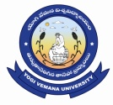
Admission into 4th Year of 4 year UG degree (Honors) Programmes
(Academic Year 2023-24)
Yogi Vemana University, Kadapa
(YVU College/ YVU Affiliated Colleges)
notification
Applications are invited from B.Sc.,/B.Com/B.A/B.B.A/B.C.A candidates for admission into 4th year of 4year UG Degree with Honors programmes.
Last Date for submission of Application: 25-11-2023
For details visit: www.yvu.edu.in Director, DOA, YVU.

